Instructions for ICIDIC’18 Camera-Ready Full Paper Submission

Full First Author ^{1,a} ,Full Second Author^{1,b*} and Full Third Author ^{2,c}
^{1*}Institute of ABC, University of Somewhere ...
²Institute of XYZ, University of Somewhere Else ...
ªE-mail,^{b}E-mail,^{c}E-mail

Abstract

This sample document provides the authors with information and instructions to prepare camera-ready submission to the 2018 The 11th International Conference on Interdisciplinary Design and Industrial-Academic Collaboration. Accepted papers will be published in conference proceedings with an abstract version in print copy and a full version in CD. Failure to follow this format may result in a submission being rejected for publication.
Keywords: Proceedings, Paper Style
1. Introduction
The size of the short paper with 4 or 6 printed pages including figures, tables and references will be charged NTD. 1000, The size of the long paper with 8 or 10 printed pages including figures, tables and references will be charged NTD. 1500, Extra pages is not allowed. You should submit an abstract version (for print-copy) via website https://form.jotform.me/40658197106458 before April 09, 2018. The author notification is April 16, 2017, you should then submit a full version (for CD) of your camera-ready paper via website https://form.jotform.me/40658197106458 (will be updated) before April 23, 2017, in order to ensure the inclusion of your paper in the proceedings.
2. General Guidelines
The paper must be written in Chinese or English, A4 paper, single-spaced, justified, with a font size of 11pt, in Times New Roman.
The title should be written centered, in 16pt, boldface Times New Roman, initial capital letters. It should be single spaced if the title is more than one line. The authors’ names, affiliations, and e-mail addresses should be written centered, in 11pt, boldface Times New Roman.
Set first-level headings in the text to the left, typed in 12pt, boldfaced and all capitalized letters. Sub-headings greater than first-level headings should be typed in 12pt, boldfaced with initial cap for first word. Be sure to leave a single line above and below each heading to separate it from the text.
2.1 Figures, Tables, and Equations
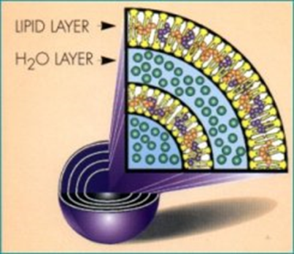
All figures and tables should be numbered consecutively and captioned, and be placed in text as close to the reference as possible. The caption title should be written centered, in 11pt bold Times New Roman, with initial capital. Figure captions should be centered beneath the figure, and table captions should be centered above the table body.
Figure 1. Intelligent Living Technology

Table 1. Table captions
Margins (cm)
top | bottom | left | right
2.5 | 2.5 | 2.5 | 2.5

A displayed equation is numbered, using Arabic numbers in parentheses. It should be centered, leaving a half line space above and below as the following example illustrates.
(1)
2.2 Margins
The margins on each side (top, bottom, left, and right) should be 2.5 cm. Refer to this example of the column width and distance.
2.3 References and Citations
References should be grouped together at the end of the paper, ordered alphabetically by authors, and referenced by numbers in brackets [1]. The body text of the references should be 11pt Times New Roman.
Acknowledgements
The MOST research grant code should be provided here if the work of this paper is supported by the Ministry of Science and Technology, Taiwan.
References
[1] Katz, D.＆ R. L. Kahn (1978), The Social Psychology of Organization, N. Y.: Johnson Willey ＆ Sons Inc.
[2] Meredith, D., Anisya, S. T.＆ Rodger, B. S.(2002). Predicting Expatriate Job Satisfaction: The Role of Firm Internationalization, Career Development International, 7(1), 24-36.
[3] Shefrin , H., & Statman, M. ( 1998 ). Comparing expectations about stock returns to realized returns , Santa Uara University, unpublished paper.
[4] Wall, J. P. (1983). Work and nonwork correlates of the career plateau . Paper presented at the annual meeting of the Academy of Management, Dallas.
[5] Williams, M. D., Hollan, J. D., & Stevens, A. L. (1983). Human reasoning about a simple physical system. In A. L. Stevens & D. Gentner (Eds.), Mental models (pp.131-151). NJ: Lawrence Erlbaum Associates.

